Weather Application

This document is a walkthrough and specification of the React Native weather application.

# Features

This application contains the following features

* View current weather forecast for the user’s current location
* View 5 day forecast for the current location
* Search for a city and retrieve the current and 5-day weather forecast
* User can add and view favourites
* User View favourites using google maps
* View offline weather forecast

# Application walkthrough

## Weather Forecast

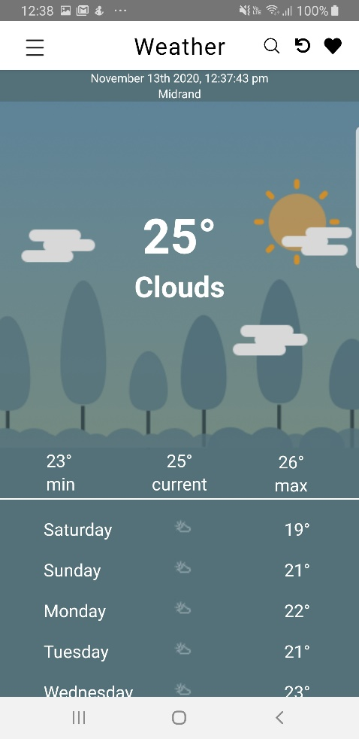Application will request the user to allow location permissions. The screen will load the current forecast the current user location. A 5 day forecast will also be displayed.

## Adding favourites

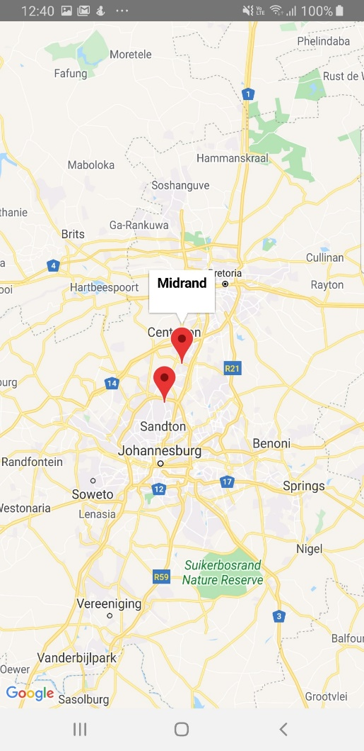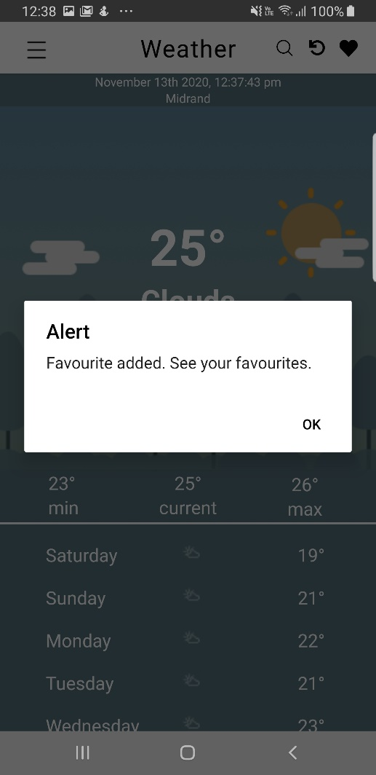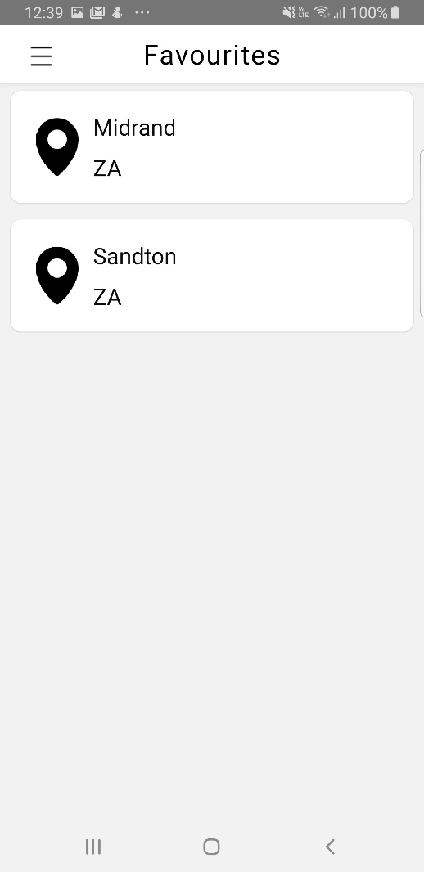The user can add their favourite location but simply selecting the “Heart” icon on the top right. This can be view by opening the drawer menu and selecting favourites option. This data is saved locally and can be viewed offline. Favourites can also be viewed using the google map feature.

## Location Search

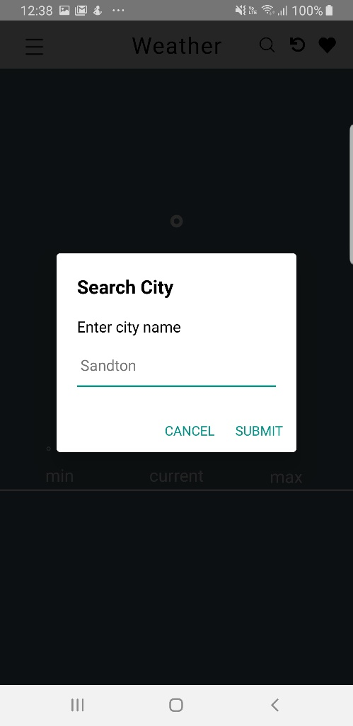This user can also get a weather forecast for other cities by selecting the “Search” icon button. A dialog will all the user to enter in the city of their choice.

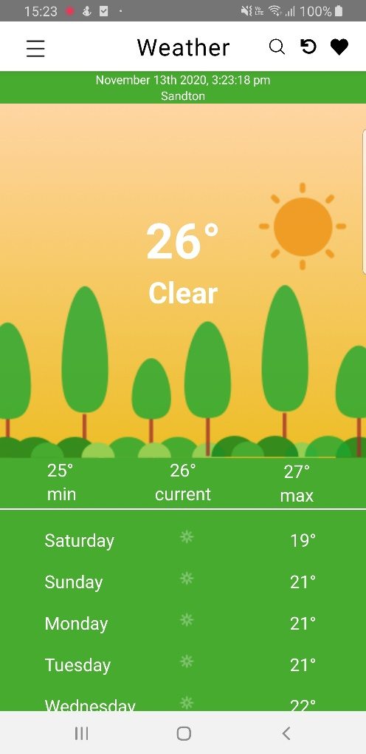

## Offline forecast

If the user is offline, they will be able to view the last location captured by the device stored locally.